Module 01
Aim : Study of NIST model of cloud computing
Objective: Understand deployment models, service models, advantages of cloud computing.

Theory:
Cloud computing is a model for enabling convenient, on-demand network access to a shared pool of configurable computing resources (e.g., networks, servers, storage, applications, and services) that can be rapidly provisioned and released with minimal management effort or service provider interaction.
This cloud model is composed of five essential characteristics, three service models, and four deployment models.
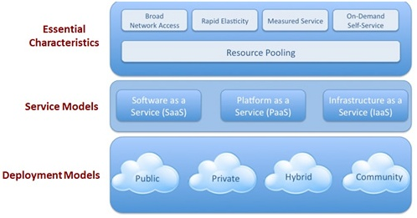
Figure 1.1 Cloud model

Essential Characteristics:
- On-demand self-service. A consumer can unilaterally provision computing capabilities, such as server time and network storage, as needed automatically without requiring human interaction with each service’s provider.
- Broad network access. Capabilities are available over the network and accessed through standard mechanisms that promote use by heterogeneous thin or thick client platforms (e.g., mobile phones, tablets, laptops, and workstations).
- Resource pooling. The provider’s computing resources are pooled to serve multiple consumers using a multi-tenant model, with different physical and virtual resources dynamically assigned and reassigned according to consumer demand. There is a sense of location independence in that the customer generally has no control or knowledge over the exact location of the provided resources but may be able to specify location at a higher level of abstraction (e.g., country, state, or data center). Examples of resources include storage, processing, memory, and network bandwidth.
- Rapid elasticity. Capabilities can be rapidly and elastically provisioned, in some cases automatically, to scale rapidly outward and inward commensurate with demand. To the consumer, the capabilities available for provisioning often appear to be unlimited and can be appropriated in any quantity at any time.
- Measured Service. Cloud systems automatically control and optimize resource use by leveraging a metering capability1 at some level of abstraction appropriate to the type of service (e.g., storage, processing, bandwidth, and active user accounts). Resource usage can be monitored, controlled, and reported, providing transparency for both the provider and consumer of the utilized service.
Service Models:
- Cloud Software as a Service (SaaS).
The capability provided to the consumer is to use the provider’s applications running on a cloud infrastructure. The applications are accessible from various client devices through a thin client interface such as a Web browser (e.g., Web-based email), or a program interface. The consumer does not manage or control the underlying cloud infrastructure including network, servers, operating systems, storage, or even individual application capabilities, with the possible exception of limited user-specific application configuration settings.
- Cloud Platform as a Service (PaaS).
The capability provided to the consumer is to deploy onto the cloud infrastructure consumer-created or -acquired applications created using programming languages and tools supported by the provider. The consumer does not manage or control the underlying cloud infrastructure including network, servers, operating systems, or storage, but has control over the deployed applications and possibly application hosting environment configurations.
- Cloud Infrastructure as a Service (IaaS).
The capability provided to the consumer is to provision processing, storage, networks, and other fundamental computing resources where the consumer is able to deploy and run arbitrary software, which can include operating systems and applications. The consumer does not manage or control the underlying cloud infrastructure but has control over operating systems, storage, deployed applications; and possibly limited control of select networking components (e.g., host, firewalls).
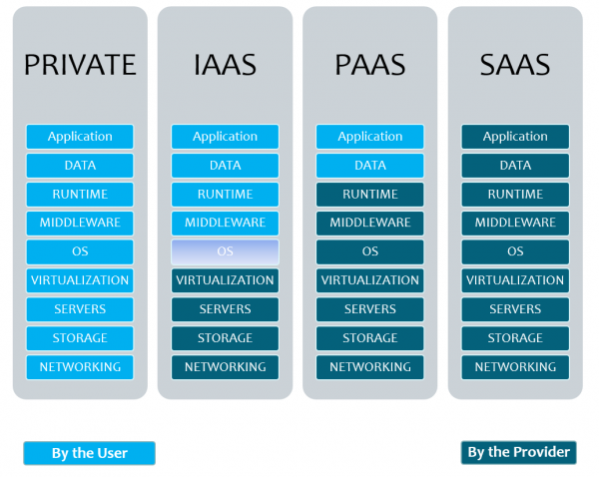
Figure 1.2 Cloud Service Model
Deployment Models:
- Private cloud. The cloud infrastructure is provisioned for exclusive use by a single organization comprising multiple consumers (e.g., business units). It may be owned, managed, and operated by the organization, a third party, or some combination of them, and it may exist on or off premises.
- Community cloud. The cloud infrastructure is provisioned for exclusive use by a specific community of consumers from organizations that have shared concerns (e.g., mission, security requirements, policy, and compliance considerations). It may be owned, managed, and operated by one or more of the organizations in the community, a third party, or some combination of them, and it may exist on or off premises.
- Public cloud. The cloud infrastructure is provisioned for open use by the general public. It may be owned, managed, and operated by a business, academic, or government organization, or some combination of them. It exists on the premises of the cloud provider.
- Hybrid cloud. The cloud infrastructure is a composition of two or more distinct cloud infrastructures (private, community, or public) that remain unique entities, but are bound together by standardized or proprietary technology that enables data and application portability (e.g., cloud bursting for load balancing between clouds)."
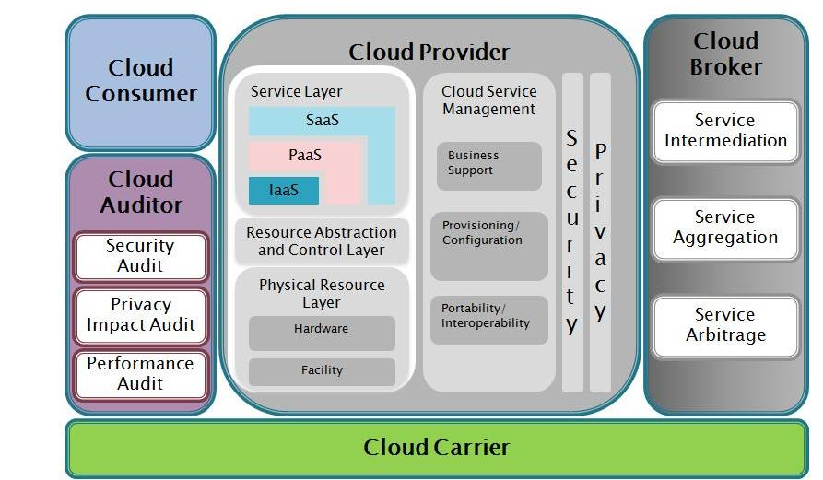
Figure 1.3 NIST Reference Architecture of Cloud Computing

Conclusion:
The features of cloud, the services provided by it shows that the cloud computing is highly reliable computing paradigm where the consumer can use large amount of computing resources as per his/her demand without actually owning it.

Program  Execution/  formation/  correction/  ethical practices  (07) | Documentation  (02) | Punctuality  (01) | Viva Answer  (05) | Experiment  Marks (15) | Teacher Signature with date

